



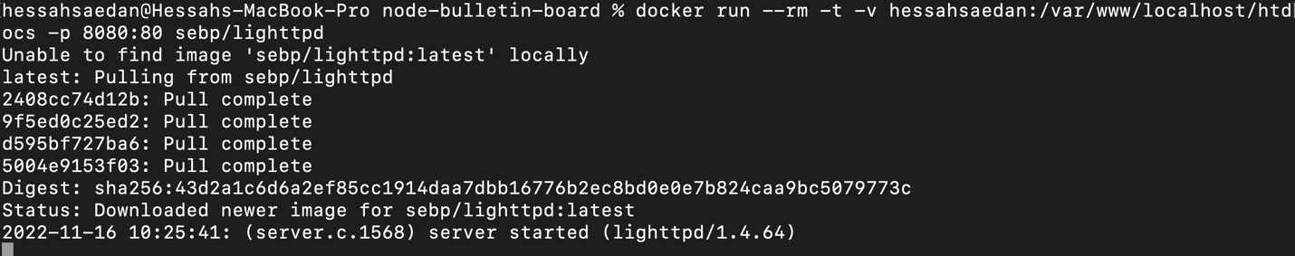

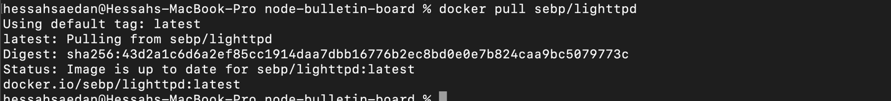

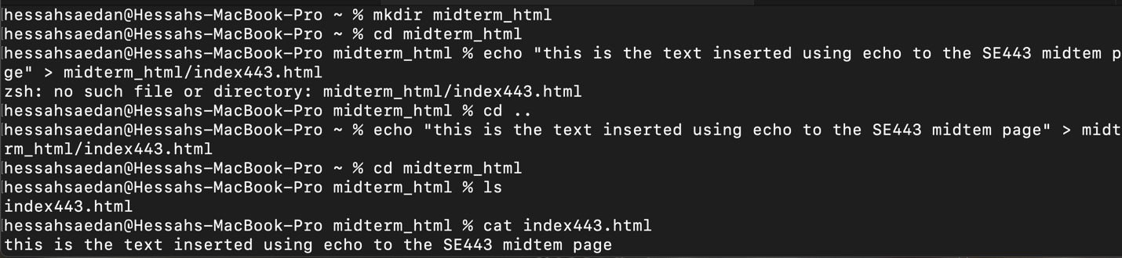

hessahsaedan@Hessahs-MacBook-Pro ~ % mkdir midterm_html

hessahsaedan@Hessahs-MacBook-Pro ~ % cd midterm_html

hessahsaedan@Hessahs-MacBook-Pro midterm_html % echo "this is the text inserted using echo to the SE443 midtem page" > midterm_html/index443.html

hessahsaedan@Hessahs-MacBook-Pro midterm_html % cd ..

hessahsaedan@Hessahs-MacBook-Pro ~

% echo "this is the text inserted using echo to the SE443 midtem page" > midterm_html/index443.html

hessahsaedan@Hessahs-MacBook-Pro ~ % cd midterm_html

hessahsaedan@Hessahs-MacBook-Pro midterm_html % ls

index443.html

hessahsaedan@Hessahs-MacBook-Pro midterm_html % cat index443.html

this is the text inserted using echo to the SE443 midtem page



hessahsaedan@Hessahs-MacBook-Pro ~ % docker run --name hessah -d -p 8008:80 -v /Users/hessahsaedan/midterm_html:/usr/share/nginx/html nginx

109da57ae62e59ab6ae0940155d6a8a14a59f02e1fd67f2a166996f6e65ecb3b

The html file is created and exists but the webpage shows “403 forbidden” tried many networks but nothing works…

